* **Activity 2:**

Creating Joins with the USING Clause



OUTPUT:

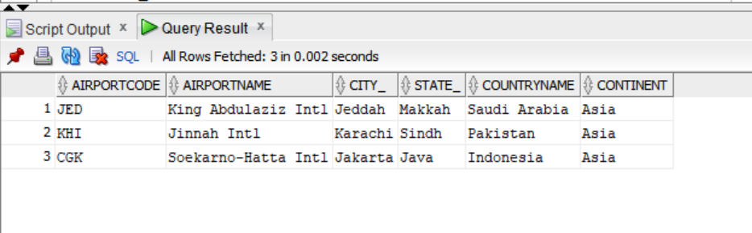

**Adding LOCATION_ID Analogy**

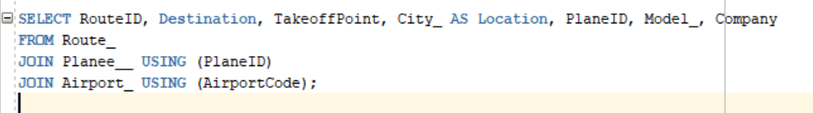

OUTPUT:

